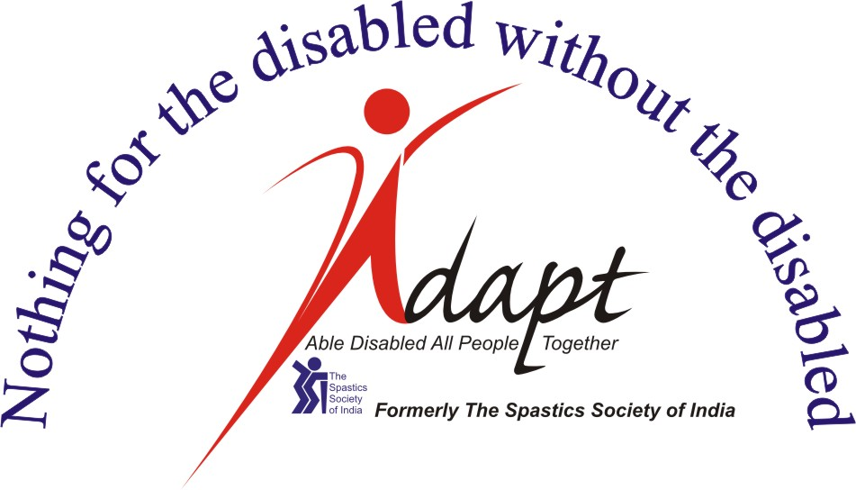

ADAPT / The National & Asian Resource Centre For Inclusion

Application for Admission to the Certificate Course
Please stick your current passport photo here

Community Initiatives in Inclusion

for the Asia Pacific Region
CII 2026

NAME (in Block Letters)

DATE OF BIRTH:_________ SEX: M / F _____ MARITAL STATUS : ____________ NATIONALITY: _____________

EMAIL ADDRESS: ____________________________________PERSONAL CELL No:__________________________

WhatsApp number/ zoom ID:__________________________________________

PERMANENT ADDRESS: | TERM ADDRESS:
OFFICE ADDRESS:

PIN: STATE: TEL. NO. | PIN: STATE: TEL. NO.

QUALIFICATION RECORDS: ATTACH PHOTOCOPY (from SSC onwards)

EXAMINATION PASSED /DEGREE | NAME OF UNIVERSITY/ BOARD | YEAR | SUBJECTS | MARKS & CLASS | DISTINCTION / AWARDS (if any)

EMPLOYMENT RECORDS / DETAILS OF WORK EXPERIENCE: ATTACH PHOTOCOPY

NAME OF THE ORGANIZATION / INSTITUTION / HOD | DESIGNATION | NATURE OF DUTIES | PERMANENT / TEMPORARY | DURATION | HOD EMAIL ID | HOD’s TELL NO

ANY ASSISTANCE OR SUPPORT REQUIRED (WHEELCHAIR, BRAILLE BOOKS, ETC)

ARE YOU SUFFERING FROM ANY ILLNESS? OR DO YOU HAVE ANY HEALTH ISSUE? IF YES, PLEASE SPECIFY. (Please attaché the necessary documents if you have)

_____________________________________________________________________________

_____________________________________________________________________________

_____________________________________________________________________________

IF YOU HAVE ANY ALLERGY, PLEASE MENTION BELOW

_____________________________________________________________________________

_____________________________________________________________________________

_____________________________________________________________________________

DO YOU HAVE A DISABILITY? IF YES, PLEASE SPECIFY. (Please attaché the necessary documents if you have)

_____________________________________________________________________________________

_____________________________________________________________________________________

_____________________________________________________________________________________

PLEASE ATTACH HEALTH INSURANCE DOCUMENTS WITH THIS APPLICATION, PLEASE MENTION YES OR NO
IF YOU ATTACHED IT

________________________________________________________________________________________________

EXTRACURRICULAR ACTIVITIES:

EXPERIENCE OF COMMUNITY WORK, PLEASE SPECIFY THE NATURE AND DURATION OF WORK.

PLEASE STATE REASONS FOR WISHING TO JOIN THIS COURSE AND WHAT YOU HOPE TO GAIN FROM IT:

I HEREBY DECLARE THAT DETAILS FURNISHED ABOVE ARE TRUE AND COMPLETE.

PLACE:____________

DATE:______________
SIGNATURE OF THE APPLICANT

NOTE TO THE APPLICANT:

- The completed application should reach:  Mrs. Sujata Verma  Director Training and Pedagogy and CII course  trginfo.adapt@gmail.com, ciiadapt@gmail.com  ADAPT (Formerly The Spastics Society of India)  K.C. Marg, Bandra Reclamation, Mumbai – 400 050.  Tel: ++91 84540 55774 / +91 99871 09505 / +91 75066 75797 | - Enclose copies of the following certificates:  - Secondary & Higher Secondary Mark Sheets  - Degree Certificate/Mark Sheet (if final results are awaited the mark sheets of previous years)  - Work experience certificate, if applicable.  - Disability Certificate, if applicable  - Health-related document/s, if applicable  F. Copy of your Photo ID, valid passport / Aadhar card  - Use additional sheet (s) if needed

